Galla Jagan Kumar

20018784

**Mongo dB Assignment**

* Please find out how many posts have “Likes” larger than 5

Ans : db.FB.find({ "Likes": { $gt: 5 } }).count()

Output

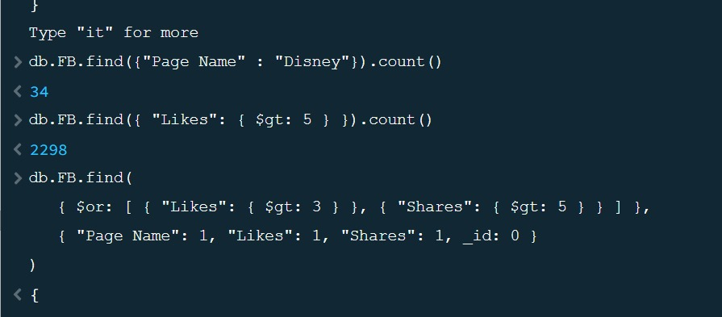

Please find out how many posts have “Likes” larger than 3 or “Shares” larger than 5, and the output only display the “Page Name”, “Likes”, and “Shares”  
(If the data type of “Shares” is a string, you need to change the data type of “Shares”)

Ans

db.FB.find(

{ $or: [ { "Likes": { $gt: 3 } }, { "Shares": { $gt: 5 } } ] },

{

"Page Name": 1, "Likes": 1, "Shares": 1, _id: 0 }

)

* Please find out the Top 3 Facebook accounts which have the largest number of “Likes” (you need to only display the “Page Name” and “Likes” of these accounts)

Ans

db.FB.find({}, { "Page Name": 1, "Likes": 1, _id: 0 }).sort({ "Likes": -1 }).limit(3)

output

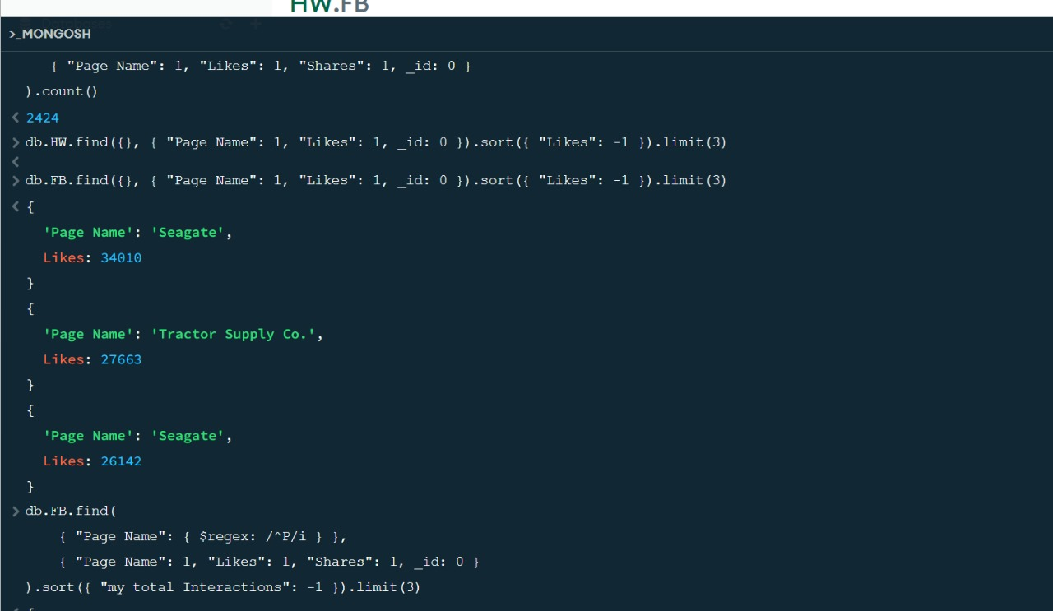

* For those accounts with names starting with the letter “P”, please find out the Top 3 Facebook accounts which have largest number of “my total Interactions”. (my total Interactions = “Likes” + “Shares”) (you need to only display the “Page Name” and “my total Interactions” of these accounts).

Ans

db.FB.aggregate([

{

$match: {

"Page Name": { $regex: /^P/i }

}

},

{

$project: {

"Page Name": 1,

"my total Interactions": { $sum: ["$Likes", "$Shares"] },

_id: 0

}

},{

$sort: {

"my total Interactions": -1

}

},

{

$limit: 3

}

])